Dial-Up Networking for Windows ‘95/’98

Minimum Requirements
- Microsoft Windows ’95 or Windows ‘98
- Personal Computer with 8MB RAM
- 486 or better CPU (the faster the better)
- Modem (14.4 kbps or faster)

NOTE: If you only wish to access Pegasus and not the Internet, then use HyperTerminal instead of Dial-up Networking. See the dial-up instructions on how to set up your session and your modem.

Installing Dial-up Networking on your computer
When installing Windows ’95 or ‘98, you are given the choice to install Dial-up Networking on your computer. If you are not sure you installed Dial-up Networking, go to the control panel (Start → Settings → Control Panel), and select ‘Add/Remove Programs’. In this area there are three tabs, the second of which says ‘Windows Setup’. In the ‘Communications’ section under this tab (double click the ‘Communications’ item), there should be a check mark by the ‘Dial-up Networking’ label. Click ‘OK’ to get out of this window, and the window for the ‘Add/Remove Programs’. You will need your windows ‘95/’98 program disks (or CD) in order to install this program.

Configuring Dial-up Networking
To start Dial-up Networking, click on the icon in the Accessories group (Start → Programs → Accessories → Dial-Up Networking). The ‘Make New Connection’ Wizard should appear. If it does not, double click on the ‘Make New Connection’ icon to start the program. The image below is the first window of the ‘Make New Connection’ Wizard:

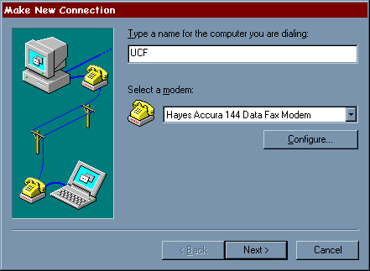

In the box underneath ‘Type a name for the computer you are dialing:’ enter UCF. The modem section should already have your modem listed in it. Note: If your modem has not been setup up already the ‘Install Modem Wizard’ will start automatically and set up your modem. Click on the ‘Next’ button, and the following window will appear:

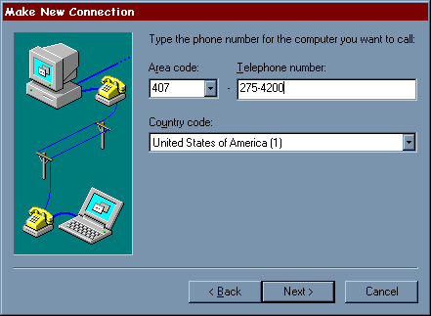

In the ‘Telephone number’ area type one of the following numbers:

(407) 235-4201 Main UCF campus and Orlando area (Student)
(407) 235-4220 Main UCF campus and Orlando area (Faculty/Staff)
(407) 636-9985 Brevard area
(904) 255-9906 Daytona area

Note: If you are dialing from on campus, you will need to add a ‘7,’ to the beginning of the phone number to dial in. Click on the ‘Next>’ button to continue. The next box tells you that your connection is finished. Click on the ‘Finish’ button to exit out of the Wizard. You should now see a window called ‘Dial-Up Networking’ with two images in it. Right click on the ‘UCF’ icon and then click on ‘Properties’ as shown in the following image:

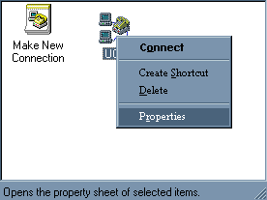

This should bring up a properties window as shown below:

NOTE: If you have a newer version of Windows 95/98, you may see a different window than from what is shown in this handbook. However, the configuration process will still be the same. If you have difficulty, please call the E-Mail and Internet Help Desk (823-5117) for assistance.

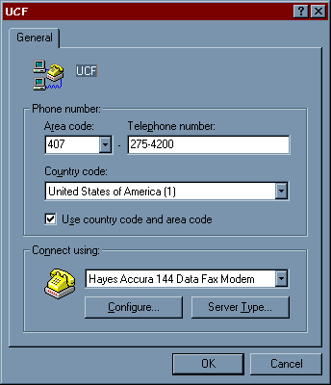

First click on the ‘Configure’ button, and then click on the ‘Options’ tab. The following window should appear:

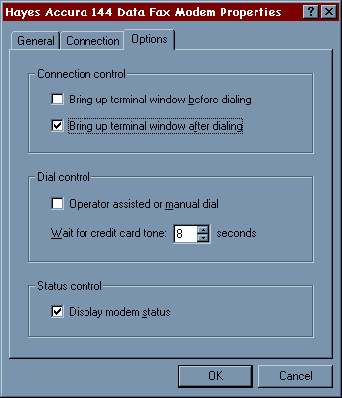

In this area click on the ‘Bring up terminal after dialing’ check box. Click on the ‘OK’ button. This will return you to the original Wizard screen. Click on the ‘OK’ button. After the window closes, click on the ‘Server Type’ button. This will bring up another window. In this window make sure that the ‘Log on to network’ option is not checked. If this option is checked, click on the check mark area to deselect it or you will have problems connecting later. In the section labeled ‘Allowed Network Protocols’ make sure that only TCP/IP is selected. The windows should look like the following:
(continued on next page)
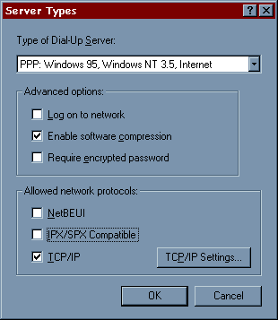

Press the ‘TCP/IP Setting button. This brings up another window. In this section, make sure that ‘Server assigned IP address’ is selected. Click on ‘Specify name server addresses’ and then put the following information into the fields:

Primary DNS: 132.170.240.15
Secondary DNS: 132.170.249.15

Make sure that the option for default gateway is enabled. When you are finished the window should look like the following:

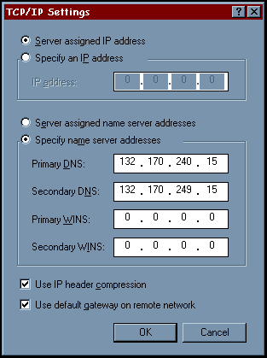

Click the ‘OK’ button to exit out of the ‘TCP/IP Settings’ area, click the ‘OK’ button to exit out of the ‘Server Settings’ area, and click the ‘OK’ button to exit the properties of this connection.
Using Dial-up Networking to connect to the Terminal Server
To dial into the system, double click the ‘UCF’ icon in the ‘Dial-Up Networking’ window. This will bring up a dialing window. Click the ‘Connect’ button to call the terminal server. The modem will dial, and after the modem connects, a terminal window will appear, with a prompt asking for your ‘Username:’. Enter in your login id for Pegasus and press <ENTER>. The next prompt will ask you for your ‘Password:’. Enter in your password for your Pegasus account and press <ENTER>. At this point you will see a prompt similar to as5100-xx>. Type in ‘ppp’ and press <ENTER>. You will then see something similar to the following messages:

Entering PPP mode.
Async interface address is unnumbered (Ethernet0)
Your IP address is 132.170.nnn.nnn. MTU is 1500 bytes

At this point click the ‘Continue’ button on the terminal window (or press F7). The system will then tell you that you are connected to the system, and the speed that you are connected at.

Now that your connection is established you can open your TCP/IP applications, such as Internet Explorer or Netscape (Web Browsers). If you wish to use Netscape instead of Internet Explorer and do not have Netscape, use Internet Explorer to access the Pegasus download page at the following address:

http://pegasus.cc.ucf.edu/~help/download/

Save the file on your pc hard drive, and then click on My Computer, then C: (the C drive). When the window opens, type in the name of the file you downloaded. Netscape will then be installed on your pc.

If you wish to log on to Pegasus, click on Start, then Run. When the window opens, type the following:

telnet pegasus.cc.ucf.edu

Or if that does not work:

telnet 132.170.240.30

Then click on the ‘OK’ button. After a few seconds, a login prompt will appear where you can type your Pegasus login name.

Troubleshooting

I’m connecting to the system, but nothing else happens.
Make sure that you have selected the ‘open terminal after dialing option’ in the modem configuration/options dialog box.

I’m connecting and logging in, but I get an error message stating that Dialup Networking cannot log into system.
Make sure that you have turned off the ‘Log into system’ option in the ‘Server Types’ Dialog Box.

I’m connecting through to the system, but then I cannot access anything on the Internet. Every time I attempt to go somewhere I get a ‘No DNS entry’ or ‘Domain Name failed’ error.
Check and make sure that you have entered in the correct settings for the DNS in the properties/server_type area, and that the ‘use default gateway on remote network’ option is selected.

I’m connected to the system, but I get an error message stating that Dialup Networking cannot negotiate the requested protocols.
First make sure that in the ‘Server Types’ section only the ‘TCP/IP’ protocol is selected. If it is, then enter the Control Panel (Start → Settings → Control Panel) and double-click on the ‘network’ icon. You will see a screen similar to the following:

NOTE: If you have a newer version of Windows 95 or 98, you may see a different window than from what is shown in this handbook. However, the configuration process will still be the same. If you have difficulty, please call the E-Mail and Internet Help Desk (823-5117) for assistance.

Under ‘The following network components are installed: ’ you will see a list; make sure that three things are in that list:

- Client for Microsoft Networks (Microsoft Family Logon for 98 users)
- Dial Up Adapter
- TCP/IP

If Client for Microsoft Networks isn’t there, click on the ‘Add’ button and double click on ‘Client’. Select ‘Microsoft’ under ‘Manufacturers: ’ and ‘Client for Microsoft Networks’ under ‘Network Clients: ’, then click on ‘OK’.

If Dial Up Adapter isn’t there, click ‘Add’ and double click on ‘Adapter’. Under ‘Manufacturers: ’ select ‘Microsoft’ and under ‘Network Adapters: ’ select ‘Dial Up Adapter’. Click ‘OK’ when you are finished.

If TCP/IP isn’t there, click ‘Add’ and double click on ‘protocol’. Select ‘Microsoft’ in the ‘Manufacturers: ’ box and ‘TCP/IP’ in the ‘Network Protocols: ’ box. Click ‘OK’ to add TCP/IP to the list of network components. Once it has been added, go to it in the list and double click on it. You will see a window appear called ‘TCP/IP Properties’. (Note: Windows 98 users will see a message displayed prior to this window. Disregard the message and click on “OK” to continue the setup.) There are six tabs at the top; click on the tab that says ‘WINS Configuration’. Click on the circle next to ‘Disable WINS Resolution’, then click on the ‘Bindings’ tab. Make sure that ‘Client for Microsoft Networks’ appears in the box with a check next to it, then click on the ‘DNS Configuration’ tab. Select ‘Enable DNS’ and type ‘local’ as the Host Name and ‘cc.ucf.edu’ as the Domain Name. Click in the box under ‘DNS Server Search Order’ and type ‘132.170.240.15’, then click on ‘Add’. Go back to the box and type ‘132.170.249.15’ and click on ‘Add’ again. Finally, click in the box under ‘Domain Suffix Search Order’ and type ‘ucf.edu’, then click on ‘Add’. The DNS Configuration window should look like the following when you are done:

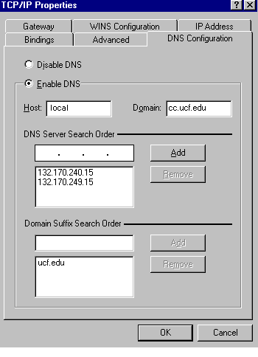
Click on the ‘OK’ button at the bottom of the screen and you will be returned to the screen with the list of network components. Click on the ‘OK’ button at the bottom of that screen and you will be asked to restart the computer to make the changes take effect. Restart your computer, then go to your UCF icon in the Dial Up Networking folder and try to connect again. Any problems, please contact the Help Desk at (407) 823-5117.

SUMMARY OF TERMINAL SERVER SETTINGS

This section gives settings that many SLIP/PPP packages require, including the Chamelion Sampler, Dialup Networking, MacPPP, and freePPP. Depending on the package you are using, not all settings may be required.

Student Phone Numbers: (407) 275-4200
(407) 513-4200

Faculty Phone Numbers: (407) 275-4220
(407) 513-4220

Brevard Number: (407) 636-9985

Daytona Number: (904) 255-9906

BAUD Rate: From 300 to 33600 (33.6Kbps)
Data Bits: 8
Stop Bits: 1
Parity: None
Flow Control: Hardware
IP Address: Dynamically Assigned
Primary Domain Name Server (DNS): 132.170.240.15
Secondary DNS: 132.170.249.15
Time Server: None (leave blank)
Netmask, Subnet Mask: 255.255.255.0
Domain: cc.ucf.edu
NMTP (News Server): news.cc.ucf.edu
SMTP (Outgoing Mail Server): pegasus.cc.ucf.edu
POP3 (Incoming Mail Server): pegasus.cc.ucf.edu
IMAP Server: pegasus.cc.ucf.edu
E-Mail and Internet Help Desk: help@pegasus.cc.ucf.edu

HELP NUMBERS

- Brevard Susan Striby (407) 632-1111 x65588

- Daytona Daytona Campus (904) 255-7423

- Main and Downtown Computer Services Help Desk (407) 823-5117
Campus

